Holiday Texture Hunt Exploringthe art element of Texture through Printmaking
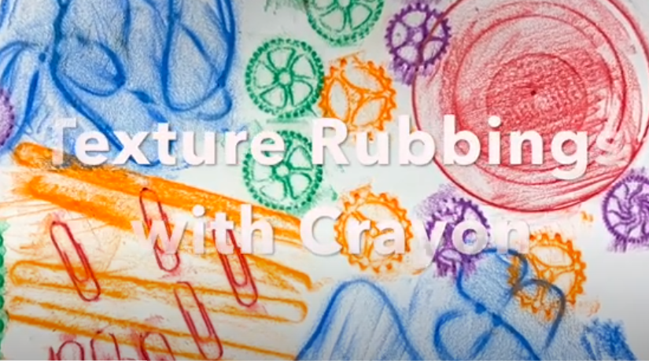 | Name_____________________________________________________________ Due 1/3/22  Texture hunt https://www.youtube.com/watch?v=KHGamhZ64l8- view to get a better idea of technique and materials  - I can explore the art element of texture  - I can print 6 different examples of texture; using hard flat objects or surfaces around my home.  - I can maniplulate different media to create a printed rubbing; wax crayon or penicil.  - I can achieve a good registration that clearly defines my objects shape or shows the detail of a textural surface.

Define: What is texture? _______________________________________________________________________________________________

